Correspondent Daily

Sunshine Skyway Bridge: World's Longest Cable-Stayed Bridge

Completed in 1987, the Sunshine Skyway is the world's longest cable-stayed concrete bridge measuring 29,040 feet. The Figg & Muller Engineering Group designed the steel and concrete roadway located in St. Petersburg and Bradenton Florida. The bridge is really something to see with its unique color -- the cables are painted a bright taxicab yellow.

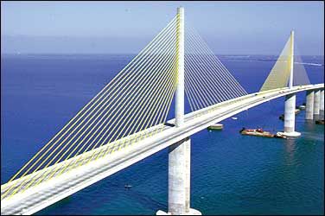
Unique yellow cables reflect its
location in the Sunshine State.
The Sunshine Skyway was built to replace a four-mile cantilever bridges that was destroyed during a violent thunderstorm in May of 1980. A freighter plowed into the bridge during the storm, knocking more than 1,000 feet of the bridge into the bay. Many people lost their lives in that accident.

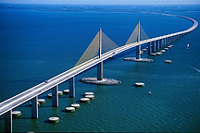
Dolphins absorb unwanted
impact from passing ships.
The Florida Department of Transportation began construction on a safer Sunshine Skyway Bridge only days later. More than 300 precast concrete segments were linked together with high-strength steel cables to form the roadway. Large concrete islands called 'dolphins' were built around each of the bridges six piers to absorb unwanted impact from passing ships. Since it opened to traffic in 1987, the sleek, new Sunshine Skyway has won dozens of engineering and design awards.

Just the Facts:

The dolphins around each pier were designed to withstand the impact of an 87,000-ton ship.
Twenty-one steel cables support the roadway.
The cables are covered in steel pipes, nine inches in diameter.
The pipes were painted a brilliant yellow to reflect its location: the Sunshine State.
Forty-foot-wide roadways run on either side of the cables. This design allows drivers to have unobstructed views of the water.
Tampa is a busy shipping port. To ensure that navigation would not be blocked, engineers designed the bridge to soar 190 feet above the water.

byline

