Correspondent Daily

Get the Gift of the Gab by Kissing the Stone of Eloquence

Get the gift of the gab by kissing the Stone of Eloquence at Blarney Castle in Ireland. This famous stone is believed to have the power to make people talk sweetly. To have this gift, a person must lie back and kiss the underneath of the stone.

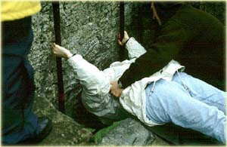
Kissing the Stone of Eloquence

Blarney Castle was built in 1446 by Dermot McCarthy. Its thick castle walls, small windows, and narrow stair cases were built to stop attacks. Tourists from all over the world travel to see the castle, kiss the stone, and walk through the beautiful gardens.

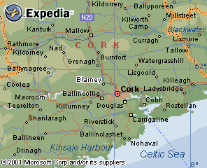
Map of Blarney, Ireland
Just the Facts:
The castle walls are 15 feet thick.
The north side of the castle is 126 feet tall.
Elizabeth 1 of England used the word “Blarney” to refer to a person who talks sweetly.
The castle is built from limestone.
In many places the castle is in ruins.
Blarney Castle is in Blarney Village which is 8 km northwest from Cork city in the South of Ireland.

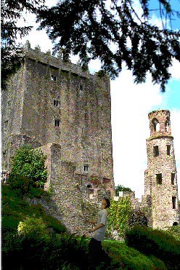
Blarney Castle

Type the "Byline"

